[Your Name or Company Name]: [Project] - Sponsorship Request
Prepared For: [Personal Contact at Company], [Company Name]
Request: [Insert the Specific Product/Serve/Request Here]
[Insert Date Here]

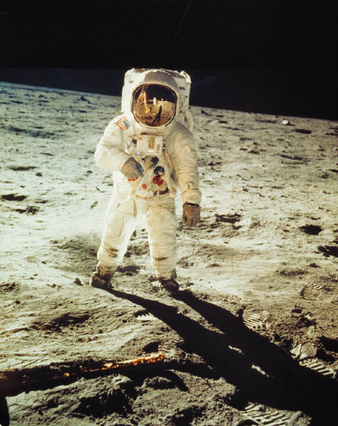
[Replace Above Picture with Your own and Insert Description of Your Picture Here]

Request you have specifically (parts) + Benefits to them
[Insert Name of Person at Sponsor Company Here],
Per our conversation on [Insert Date Here] I have created a formal sponsorship proposal for you in regards to a [Sponsorship Company Name Here] sponsorship of [Sponsor Part/Service/Gift] of [Project Vehicle / Project Event / Yourself].
As I shared with you, this project is [Insert VERY short project description] and will be on display in [Insert display/venues/showcase places here]. I’ve included a list in this document of all participating sponsors/partners as well as renderings of the final build project.
When the car/project will be completed
In this section describe the project date schedule, emphasizing when it will be done/available.
Where it will be used/featured/showcased (Details Matter)
In this section describe where the project will be used/featured/showcased. The context should be of obvious benefit to the sponsor (i.e. your project will gain visibility for them at a show/media place that would be valuable to them).
Define Project Scope & Deliverables
This is the heart of the matter! Describe specifically what their participation in your project will be, by part and component if necessary, and describe the Deliverable YOU HAVE to give back to them in return.
Why you are sponsor worthy (i.e. your background)
This is your personal background section to showcase your sponsor worthiness. Have you made a name for yourself? If so, show it here. Have you won awards? Have you been noticed by other sponsors? Do you have followers world wide? Have you won races of notoriety (that the sponsor will be aware of)? This is the place to show it!
Thank you again for your consideration of our project!
-[Insert Your Name Here]
Media – this one is iffy – and don’t mention specific outlets unless the deal is already done.
p.s. Here are a few links for your perusal regarding the [Insert Project Media Coverage Here]
1
2
3
4

Other Project Sponsors Here:

YOUR PROJECT Sponsors

1
2
3
4

